What is electricity?

First, let’s look at the atom. If you could take something and break it down small enough you’d find that everything is made of atoms. Atoms are teeny tiny particles that are too small for us to see with our eyes. Because they’re so small it’s hard to say what one really looks like, but we do know what they’re made up of. So let’s draw an atom like this.
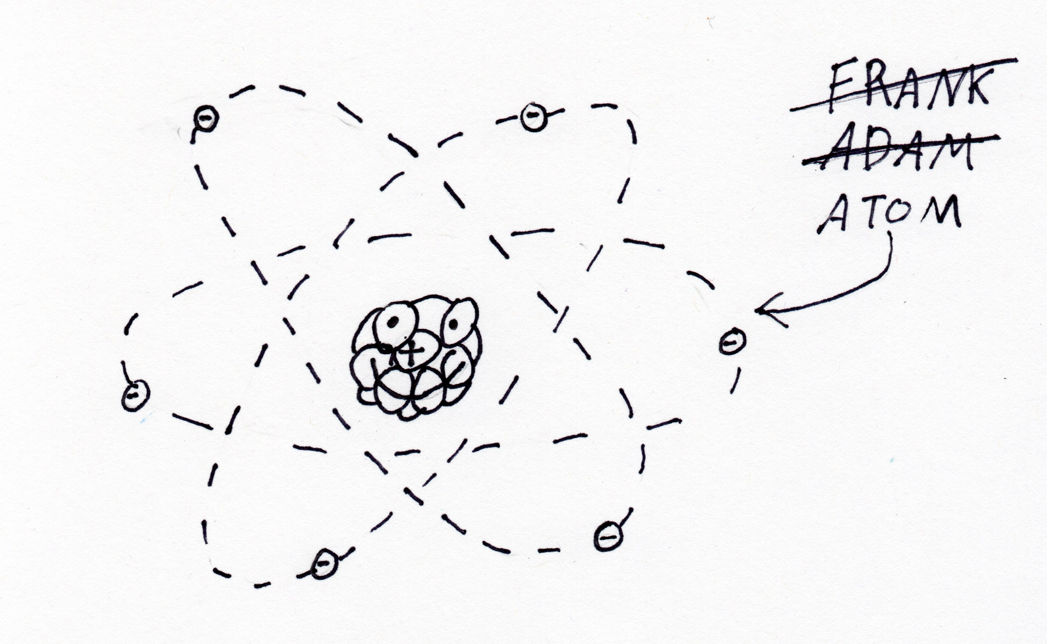

There’s lots of kinds of atoms, but they all have similar parts. The center of the atom is called the nucleolus. It has a positive charge. Buzzing around the outside of the atom are even smaller particles called electrons. They have a negative charge. Sometimes when you put a bunch of atoms together the electrons are able to move from one to another easily. These are called conductors.

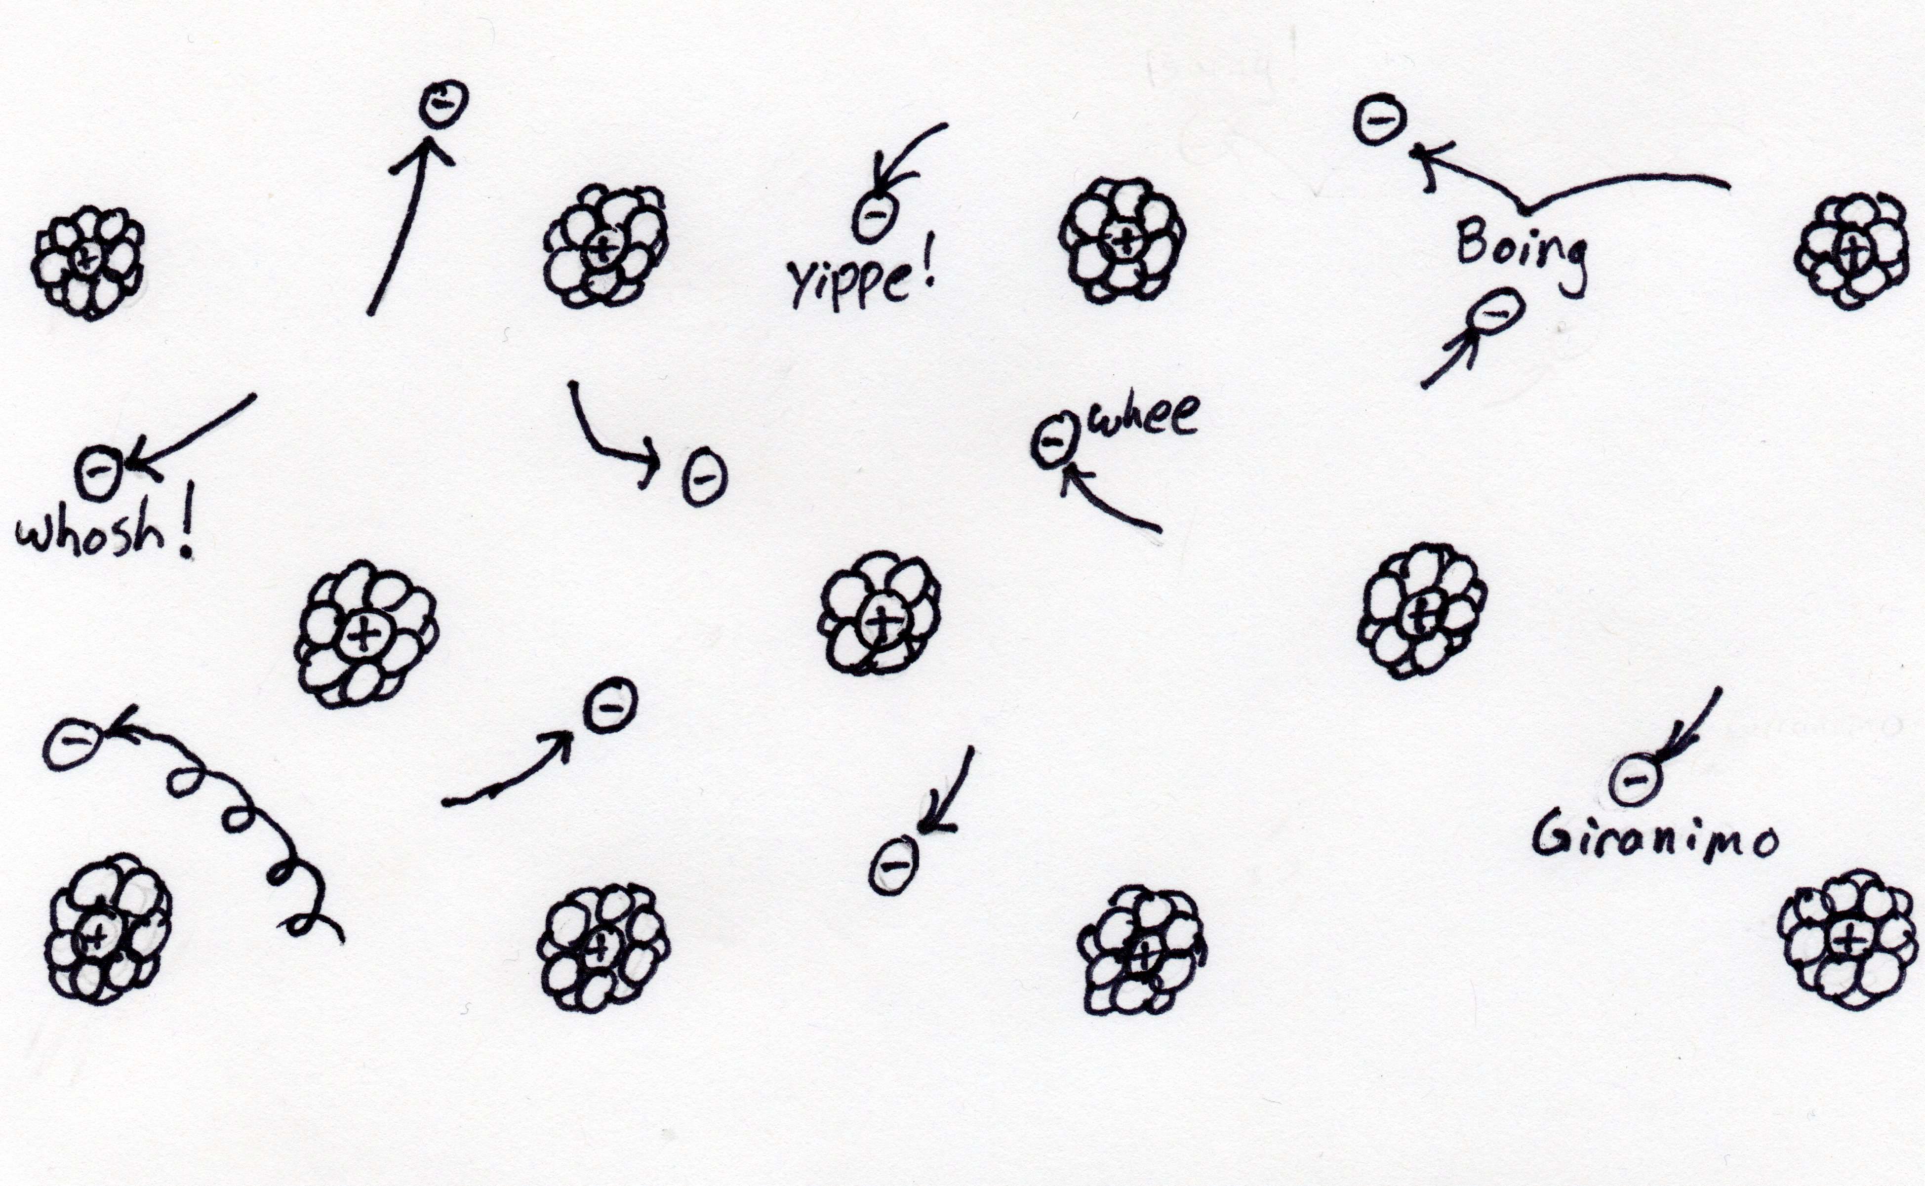

Normally the electrons will just move randomly from atom to atom with no direction. But it’s possible to push the electrons in one direction. When there’s something pushing the electrons it’s called “electro-magnetic force,” or “EMF.” Sometimes it’s just called “Voltage” because we measure it in “Volts.” The moving electrons is electricity.

<EMF Atom pic>

Imagine the moving electrons are like a river. Gravity pulls the water downhill just like the EMF pushes the electrons. The amount of water that flows down the river depends on the size and shape of the river. If it’s a wide straight river then lots of water flows down it. If it’s a small river with lots of bends then the flow slows down. The force of gravity is the same either way, but the amount of water changes because of the shape of the river

<Ohms Law River Pic>

The same thing happens with the electrons. The flow electrons is called current, just like the river current. We measure current in Amps. If there is something slowing the electrons down we call that resistance. Resistance is measured in Ohms. The path that electrons take is called a circuit.

Lab: Build an Electrical Circuit

Let’s build a circuit to see the flow of electrons. We also want to make a simple drawing to show how the circuit works. So we use symbols to represent each part or component. First we need something to generate the EMF. We’ll use a battery pack. The symbol for a battery is a bunch of short and long lines.

<Picture of battery pack and battery symbol.>

We also need something to slow down the current because we don’t to let out all the electricity from the battery at once. Well use a resistor for that. The symbol for a resistor looks like the bends in the river just like how the bends in the river slow the flow of water.

<Picture of resistor and resistor symbol>

We’re going to use one more thing called a diode. The diode is like a one-way valve - it lets the current flow one way, but not the other. Its symbol is an arrow with a line on one side. The diode we’ll use lights up when current flows through it. It’s called a Light Emitting Diode, or LED.

<picture of LED and LED symbol>

The last thing we need is wire to hook everything together. The symbol for wire is just a line that connects the other symbols.

